**C - First Sunday of Lent, March 9, 2025**

**“The Temptation” of Jesus**

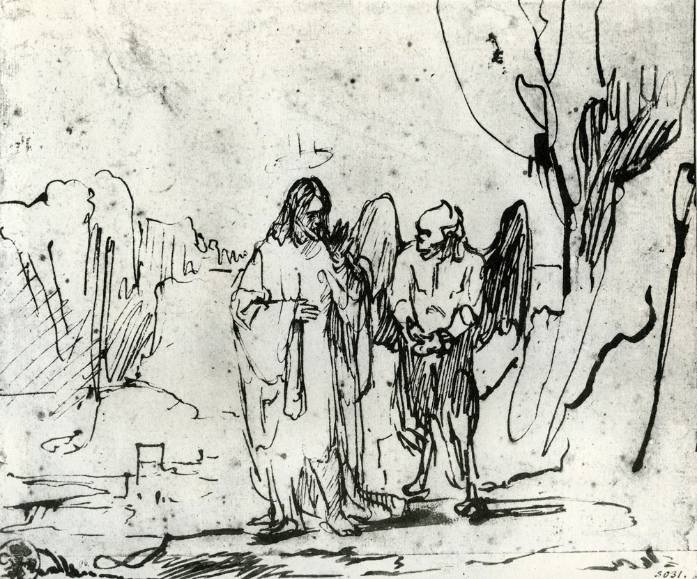

**Rembrandt van Rijn 1606-1669 – The Temptation of Christ, c. 1640 -1642**

**Introductory reflection –** According to Urantiathe temptation events after Jesus’ baptism described in Luke’s gospel of today actually occurred about four months earlier in August -September 25 A.D. Jesus did retreat into the Pella wilderness for forty days after his baptism by John on January 14, 26 A.D, but that retreat was to plan out the remainder of his life work.

In the Urantia account in August 25 A.D. Jesus went up Mount Hermon for forty days to experience alone “his last struggle with the realities of mortal existence” with only “his indwelling Adjuster to guide and sustain him.” (**Urantia 134:8.2**,) He was only accompanied by a lad named Tiglath, who brought Jesus provisions every few days. In the sixth and final week of this retreat in late September 25 A.D. Jesus struggled with and defeated his archenemies from the spiritual world, Lucifer, Satan, and the Urantia Planetary Prince, Caligastia.

Rembrandt’s sketch remarkably captures Jesus’s dialogue with Satan, representing Lucifer.

**Reading 1 – Urantia, Part IV., The Life and Teachings of Jesus, Paper 120- The Bestowal of Michael on Urantia, Section 2. The Bestowal Limitations, Paragraphs 1b, 2a, and 3 - 5**

120:2.1 (1327.1) “1. . . . You will grow up on Urantia as a child of the realm, complete your human education—all the while subject to the will of your Paradise Father—live your life on Urantia as you have determined, terminate your planetary sojourn, and prepare for ascension to your Father to receive from him the supreme sovereignty of your universe.

120:2.2 (1327.2) “2. Apart from your earth mission and your universe revelation, but incidental to both, I counsel that you assume, after you are sufficiently self-conscious of your divine identity, the additional task of technically terminating the Lucifer rebellion in the system of Satania, and that you do all this as the *Son of Man;* thus, as a mortal creature of the realm, in weakness made powerful by faith-submission to the will of your Father, I suggest that you graciously achieve all you have repeatedly declined arbitrarily to accomplish by power and might when you were so endowed at the time of the inception of this sinful and unjustified rebellion. I would regard it as a fitting climax of your mortal bestowal if you should return to us as the Son of Man, Planetary Prince of Urantia, as well as the Son of God, supreme sovereign of your universe. . . .

120:2.3 (1327.3) “3. When you have succeeded in terminating the Urantia secession, as you undoubtedly will, I counsel you to accept from Gabriel the conference of the title of ‘Planetary Prince of Urantia’ as the eternal recognition by your universe of your final bestowal experience; and that you further do any and all things, consistent with the purport of your bestowal, to atone for the sorrow and confusion brought upon Urantia by the Caligastia betrayal and the subsequent Adamic default.

120:2.4 (1328.1) “4. In accordance with your request, Gabriel and all concerned will co-operate with you in the expressed desire to end your Urantia bestowal with the pronouncement of a dispensational judgment of the realm, accompanied by the termination of an age, the resurrection of the sleeping mortal survivors, and the establishment of the dispensation of the bestowed Spirit of Truth.

120:2.5 (1328.2) “5. As concerns the planet of your bestowal and the immediate generation of men living thereon at the time of your mortal sojourn, I counsel you to function largely in the role of a teacher. Give attention, first, to the liberation and inspiration of man’s spiritual nature. Next, illuminate the darkened human intellect, heal the souls of men, and emancipate their minds from age-old fears. And then, in accordance with your mortal wisdom, minister to the physical well-being and material comfort of your brothers in the flesh. Live the ideal religious life for the inspiration and edification of all your universe. [1]

**Reflection -** These five abbreviated instructions are part of nine bestowal limitations that the Universal Father conveyed to Michael of Nebadon (through a divine son, Immanuel) before Michael’s seventh and final bestowal to earn full sovereignty of his local universe of 10,000,000 inhabitable planets. These instructions place the confrontation with Satan in a much broader, divine context. How fortunate we are on our world of two previous defaults that Michael chose to incarnate on Urantia. This reflects divine concern and mercy towards our ill-fated planet.

**Responsorial Psalm -** [**Psalm 91:1-2, 10-11, 12-13, 14-15**](https://bible.usccb.org/bible/psalms/91?1) [2] **R. (cf. 15b)** **“When you call out to me, I will answer.”**

“The one who dwells in the shelter of the Most High sleeps in the shadow of God’s breast. I name the Eternal my refuge and fortress; my God in whom I place my trust.” **R. “When you call out to me, I will answer.”**

“You will encounter no sorrow. No plague will come near your tent. The Holy One will command angels to guard you on all your paths.”  
**R. “When you call out to me, I will answer.”**

“On their hands they will carry you lest you hurt your foot on a rock. Upon lions and cobras you will walk safely; serpents and young lions you will trample down.”   
**R. “When you call out to me, I will answer.”**

*“Because you cling to me in love,* says God, *I will carry you safely away. I will lift you up, for you know my name. When you call out to me, I will answer. I am with you in times of affliction. I will release you from harm and illumine your honor.”*  **R. “When you call out to me, I will answer.” [3]**

**Reflection –** Jesus in his life on Urantia reflects this confidence in the loving support of his Father and our Father found in this Hebrew testament psalm of hope and appreciation.

**Reading 2** **– Urantia Part IV - The Life and Teachings of Jesus, Paper 134 – The Transition Years, Section 7. The Thirty-First year (A.D. 25), Paragraphs 6 – 7 and Section 8. The Sojourn on Mount Hermon, Paragraphs 3 - 5.**

134:7.6 (1492.6) The indwelling Thought Adjuster now led Jesus to forsake the dwelling places of men and betake himself up to Mount Hermon that he might finish his work of mastering his human mind and complete the task of effecting his full consecration to the remainder of his lifework on earth.

134:7.7 (1492.7) This was one of those unusual and extraordinary epochs in the Master’s earth life on Urantia. Another and very similar one was the experience he passed through when alone in the hills near Pella just subsequent to his baptism. This period of isolation on Mount Hermon marked the termination of his purely human career, that is, the technical termination of the mortal bestowal, while the later isolation marked the beginning of the more divine phase of the bestowal. And Jesus lived alone with God for six weeks on the slopes of Mount Hermon.

134:8.3 (1493.2) Jesus ate frugally while on the mountain; he abstained from all food only a day or two at a time. The superhuman beings who confronted him on this mountain, and with whom he wrestled in spirit, and whom he defeated in power, were *real;* they were his archenemies in the system of Satania; they were not phantasms of the imagination evolved out of the intellectual vagaries of a weakened and starving mortal who could not distinguish reality from the visions of a disordered mind.

134:8.4 (1493.3) Jesus spent the last three weeks of August and the first three weeks of September on Mount Hermon. During these weeks he finished the mortal task of achieving the circles of mind-understanding and personality-control. Throughout this period of communion with his heavenly Father the indwelling Adjuster also completed the assigned services. The mortal goal of this earth creature was there attained. Only the final phase of mind and Adjuster attunement remained to be consummated.

134:8.5 (1493.4) After more than five weeks of unbroken communion with his Paradise Father, Jesus became absolutely assured of his nature and of the certainty of his triumph over the material levels of time-space personality manifestation. He fully believed in, and did not hesitate to assert, the ascendancy of his divine nature over his human nature.[4]

**Reflection –** During this period on Mount Herman Jesus not only confronted the problem of reconciling his divine and human nature, but he also asserted “the ascendancy of his divine nature over his human nature.” That prepared him in the final week to confront his spiritual enemies. It seems we rarely in present times frame our struggles as being how to reconcile our spiritual and material natures.

**Verse Before the Gospel - Urantia 134:8.8 R. Praise to you Lord Jesus Christ, King of Endless Glory!**

“Jesus only made reply, ‘The will of my Father in Paradise be done.’” **R. Praise to you Lord Jesus Christ, King of Endless Glory! [5]**

**Gospel – Urantia Part IV. The Life and Teachings of Jesus, Paper 134 – The Transition Years, Section** **8. The Sojourn on Mount Hermon, Paragraph 6 – 10**

134:8.6 (1493.5) Near the end of the mountain sojourn Jesus asked his Father if he might be permitted to hold conference with his Satania enemies as the Son of Man, as (Jesus of Nazareth) Joshua ben Joseph. This request was granted. During the last week on Mount Hermon the great temptation, the universe trial, occurred. Satan (representing Lucifer) and the rebellious Planetary Prince, Caligastia, were present with Jesus and were made fully visible to him. And this “temptation,” this final trial of human loyalty in the face of the misrepresentations of rebel personalities, had not to do with food, temple pinnacles, or presumptuous acts. It had not to do with the kingdoms of this world but with the sovereignty of a mighty and glorious universe. The symbolism of your records was intended for the backward ages of the world’s childlike thought. And subsequent generations should understand what a great struggle the Son of Man passed through that eventful day on Mount Hermon.

134:8.7 (1493.6) To the many proposals and counterproposals of the emissaries of Lucifer, Jesus only made reply: “May the will of my Paradise Father prevail, and you, my rebellious son, may the Ancients of Days judge you divinely. I am your Creator-father; I can hardly judge you justly, and my mercy you have already spurned. I commit you to the adjudication of the Judges of a greater universe.”

134:8.8 (1494.1) To all the Lucifer-suggested compromises and makeshifts, to all such specious proposals about the incarnation bestowal, Jesus only made reply, “The will of my Father in Paradise be done.” And when the trying ordeal was finished, the detached guardian seraphim returned to Jesus’ side and ministered to him.

134:8.9 (1494.2) On an afternoon in late summer, amid the trees and in the silence of nature, Michael of Nebadon won the unquestioned sovereignty of his universe. On that day he completed the task set for Creator Sons to live to the full the incarnated life in the likeness of mortal flesh on the evolutionary worlds of time and space. The universe announcement of this momentous achievement was not made until the day of his baptism, months afterward, but it all really took place that day on the mountain. And when Jesus came down from his sojourn on Mount Hermon, the Lucifer rebellion in Satania and the Caligastia secession on Urantia were virtually settled. Jesus had paid the last price required of him to attain the sovereignty of his universe, which in itself regulates the status of all rebels and determines that all such future upheavals (if they ever occur) may be dealt with summarily and effectively. Accordingly, it may be seen that the so-called “great temptation” of Jesus took place sometime before his baptism and not just after that event.

134:8.10 (1494.3) At the end of this sojourn on the mountain, as Jesus was making his descent, he met Tiglath coming up to the rendezvous with food. Turning him back, he said only: “The period of rest is over; I must return to my Father’s business.” He was a silent and much changed man as they journeyed back to Dan, where he took leave of the lad, giving him the donkey. He then proceeded south by the same way he had come, to Capernaum. [6]

**Reflection -** This truly was the momentous, penultimate moment for Michael of Nebadon, as Jesus, completing his requirements to assume full and complete sovereignty of his universe, Nebadon, a requirement of all Michael Sons. Fortunately for us he chose to continue his earthly ministry of disclosing the loving fatherhood of God and our need for loving-kindness towards all our human companions on this planet.

1. **Replaced Reading 1 -** [**Deuteronomy 26:4-10**](https://bible.usccb.org/bible/deuteronomy/26?4)

   Moses spoke to the people, saying: “The priest shall receive the basket from you and shall set it in front of the altar of the LORD, your God. Then you shall declare before the Lord, your God, ‘My father was a wandering Aramean who went down to Egypt with a small household and lived there as an alien. But there he became a nation great, strong, and numerous. When the Egyptians maltreated and oppressed us, imposing hard labor upon us, we cried to the LORD, the God of our fathers, and he heard our cry and saw our affliction, our toil, and our oppression. He brought us out of Egypt with his strong hand and outstretched arm, with terrifying power, with signs and wonders; and bringing us into this country, he gave us this land flowing with milk and honey. Therefore, I have now brought you the first fruits of the products of the soil which you, O LORD, have given me.’ And having set them before the LORD, your God, you shall bow down in his presence.”
2. After and inspired by Pamela Greenberg’s **The Complete Psalms – The Book of Prayer Songs in a New Translation.**
3. **Replaced Responsorial Psalm -** [**Psalm 91:1-2, 10-11, 12-13, 14-15**](https://bible.usccb.org/bible/psalms/91?1)  **R. (cf. 15b)** **Be with me, Lord, when I am in trouble.**

   You who dwell in the shelter of the Most High, who abide in the shadow of the Almighty,  
   say to the LORD, “My refuge and fortress, my God in whom I trust.”  
   **R. Be with me, Lord, when I am in trouble.**

   No evil shall befall you, nor shall affliction come near your tent, For to his angels he has given command about you, that they guard you in all your ways.  
   **R. Be with me, Lord, when I am in trouble.**

   Upon their hands they shall bear you up, lest you dash your foot against a stone. You shall tread upon the asp and the viper; you shall trample down the lion and the dragon.  
   **R. Be with me, Lord, when I am in trouble.**

   Because he clings to me, I will deliver him; I will set him on high because he acknowledges my name. He shall call upon me, and I will answer him; I will be with him in distress; I will deliver him and glorify him. **R. Be with me, Lord, when I am in trouble.**
4. **Replaced Reading 2 -** [**Romans 10:8-13**](https://bible.usccb.org/bible/romans/10?8)

   Brothers and sisters: What does Scripture say? *The word is near you, in your mouth and in your heart* — that is, the word of faith that we preach —, for, if you confess with your mouth that Jesus is Lord and believe in your heart that God raised him from the dead, you will be saved.  
   For one believes with the heart and so is justified, and one confesses with the mouth and so is saved. For the Scripture says, *No one who believes in him will be put to shame.* For there is no distinction between Jew and Greek; the same Lord is Lord of all, enriching all who call upon him. For “everyone who calls on the name of the Lord will be saved.”
5. **Replaced Verse Before the Gospel - Matthew 4:4b R. Praise to you Lord Jesus Christ, King of Endless Glory!**

   One does not live on bread alone, but on every word that comes forth from the mouth of God.

   **R. Praise to you Lord Jesus Christ, King of Endless Glory!**
6. **Replaced Gospel -** [**Luke 4:1-13**](https://bible.usccb.org/bible/luke/4?1)

   Filled with the Holy Spirit, Jesus returned from the Jordan and was led by the Spirit into the desert for forty days, to be tempted by the devil. He ate nothing during those days, and when they were over he was hungry. The devil said to him, “If you are the Son of God, command this stone to become bread.” Jesus answered him, “It is written, *One does not live on bread alone*.” Then he took him up and showed him all the kingdoms of the world in a single instant. The devil said to him, “I shall give to you all this power and glory; for it has been handed over to me, and I may give it to whomever I wish. All this will be yours, if you worship me.” Jesus said to him in reply, “It is written *You shall worship the Lord, your God, and him alone shall you serve.*”

   Then he led him to Jerusalem, made him stand on the parapet of the temple, and said to him, “If you are the Son of God, throw yourself down from here, for it is written: *He will command his angels concerning you, to guard you*,  and: *With their hands they will support you,* *lest you dash your foot against a stone.*” Jesus said to him in reply, “It also says, *You shall not put the Lord, your God, to the test.*” When the devil had finished every temptation, he departed from him for a time.